

PRESS RELEASE – for immediate release
14 October 2026

Mary’s Meals International Appoints New Executive Director
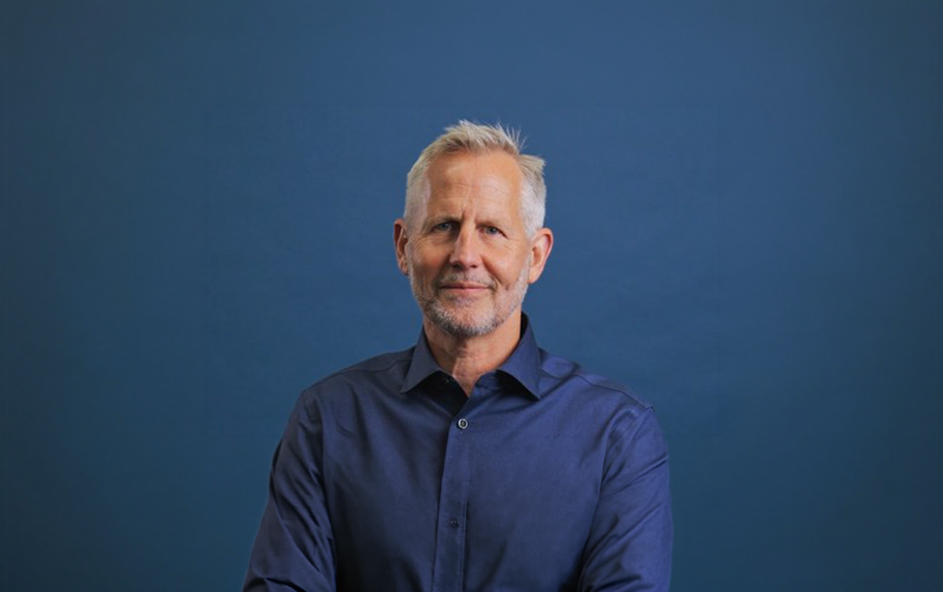

14 October 2026. Global school feeding charity Mary’s Meals International has appointed Andy Griffiths in the newly created role of Executive Director, in a move designed to strengthen the organisation for the future. Andy will lead the organisation through its 25th-anniversary year in 2027 and towards its goal of providing millions more vital school meals for children facing extreme hunger in some of the world’s most challenging regions.
Founder of Mary’s Meals, and current CEO, Magnus MacFarlane-Barrow is stepping into a new President and Founder role, allowing him more time to support the growth of the Mary’s Meals movement globally through raising awareness, various strategic initiatives and by leading on the further development of our unique values and culture.
Magnus says: “I am extremely excited to work closely with Andy who brings enormous relevant experience and welcome fresh perspective. We share an enormous passion to see every hungry child receive a meal and a confidence that Mary’s Meals can reach many more children in desperate need, without sacrificing the unique values and culture that make Mary’s Meals so special.”
Andy is set to join the organisation on 20 October and brings a wealth of experience from the NGO sector, most recently at International Justice Mission, following a successful commercial career.
John Darley, Chair of the Mary’s Meals International Board, says: “Andy’s appointment marks an exciting moment for Mary’s Meals as we look to grow our impact and feed more children. We currently reach more than 3 million children with daily school meals, but with an estimated 78 million primary-age children still out of school and millions more attending classes too hungry to learn, the need for our work has never been greater. With Andy and Magnus in their new roles we face the future with renewed vigour and determination to continue partnering with communities for long-term change, while striving to reach the next school waiting for Mary’s Meals.”
Ends
For Media Inquiries
Please contact Paloma García Ovejero, Head of Media – Mary’s Meals International: media@marysmeals.org
Notes to Editors

- Mary’s Meals is a simple idea that works. The charity provides children living in poverty with one daily meal in a place of education in areas where hunger often stands in the way of education.
- Mary’s Meals works with communities to serve vital school meals to more than 3 million children in 16 countries: Benin, Ecuador, Ethiopia, Haiti, India, Kenya, Lebanon, Liberia, Madagascar, Malawi, Mozambique, South Sudan, Syria, Yemen, Zambia and Zimbabwe.
- Our mission is to enable people to offer their money, goods, skills or time, and through this involvement, provide the most effective help in those suffering the effects of extreme poverty around the world.
- Mary’s Meals increases school enrolment and improves school attendance, while helping children to concentrate better and participate more, so they have an increased chance of progressing through education.
- Local communities own and run Mary’s Meals in the countries where the programmes operate and, wherever possible, our meals are made with locally procured food, thereby supporting local economies.
- More about Andy Griffiths: Andy worked as a lawyer at Hogan Lovells for eight years, then for seven years at ITV plc, becoming Group Director of Legal and Regulatory Affairs, and for three years as Global Head of Legal and Business Affairs at Endemol International, then the world’s largest independent TV production company. He moved to Chennai, India, with his wife and two daughters, to lead International Justice Mission’s work addressing bonded labour. After three years in India, Andy returned to London as Global Director of Governance at Visionfund (World Vision’s microfinance arm), empowering rural entrepreneurs to form businesses and move their families out of poverty. He moved to become CEO of Laureus Sport for Good, using the power of sport to end violence, discrimination and disadvantage in the lives of children and young people, funding 190 community-based organisations across 40 countries. Most recently, Andy was President for Africa and Europe region at International Justice Mission for seven years, working closely with governments in the region to tackle modern-day slavery, violence against women and children, and policy abuse of power.
Please visit marysmeals.org to find out more.

